**University of Petroleum and Energy Studies**

School of Computer Science

Department of Cybernetics



**Graphics & Animation Tools**

**VIVA-2ASSIGNMENT**

**(Session: 2020-2021)**

Course: B. Tech with Specialization in Open Source and Open Standards

Batch: 2017-2021

Semester: VIIth

**Submitted To: -**

Dr. Durgansh Sharma

Assistant Professor

Department of Cybernetics

**Submitted By: -**

Ananya Raghav

R100217008

500062570

**1) Aim-** Create any Mountain Range with Snowfall over it using GIMP.

**Steps followed**-

1. Open GIMP.
2. Create a new layer with white background.
3. Download an image of mountains.
4. Open that image of mountain as layers in GIMP.
5. Create a new transparent layer to draw boundaries.
6. Now with the ‘Paths tool’ start selection boundaries and layout of the image.
7. After selection of layout/ boundaries, go to ‘Select’, choose ‘From Path’ option and your path will be selected.
8. Use ‘bucket fill tool’ from the toolbar.
9. Repeat step 3, 4, 5 for creating the grass, river and sky of the scene.
10. Now create snow cap.
11. Place the snow cap at the top of mountain range.
12. For adding snowfall effect, add a new layer of black colour over all the layers and set the photo effect from normal to screen.
13. Go to Filters -> Noise -> RGB Noise and then press ‘OK’, this will add some noise to the image and make it translucent.
14. Then, Go to Filters -> Blur ->Motion Blurand then press ‘OK’.
15. After completing above steps, Go to Colors ->Levels and adjust the white and black input levels till you find pixelated snow effect over your image.
16. Your image is complete export it as .png and save it.

**Output-**

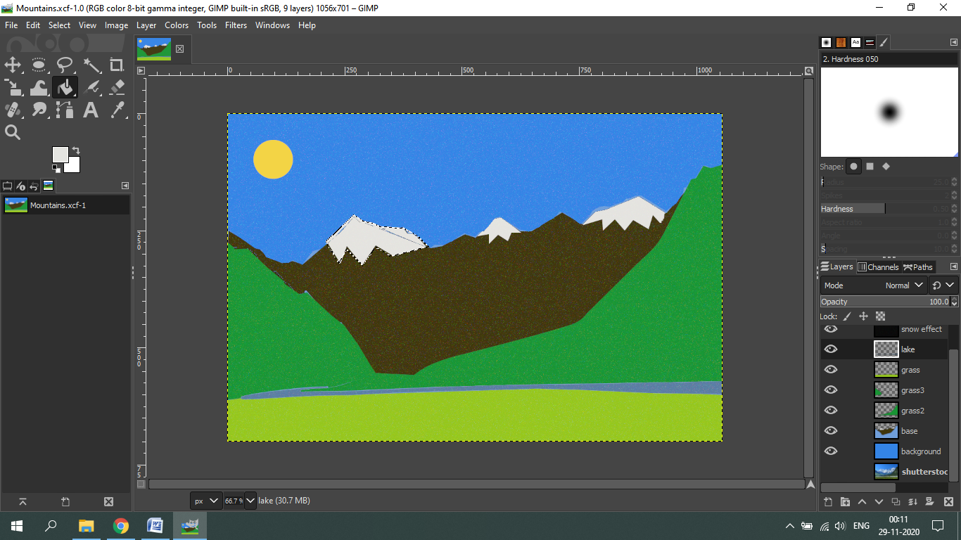

**2) Aim-** Create any City or Skyscraper using Blender.

**Steps followed:**

1. Open Blender
2. Clear the interface.
3. Start with adding a plane to act as the base.
4. Now, add a cube and scale it to look like a cuboid(main structure of the building).
5. Now, take a plane and scale it and position it on one of the sides of the base cube(to represent windows).
6. Set the surface of the plane representing windows to Glass BSDF to give a glass like effect.
7. Add the plane representing windows as per the size of the base cube.
8. Do the same as in step 5 to all the sides of the cube.
9. Now choose a front side of the building, make another plane and scale and fix it at the bottom of the base cube representing the door of the building.
10. Fill colors in all the shapes by going to Materials.
11. Select Surface and their choose the color of your choice.
12. Go to file and save it as your name and render a few pictures for the display.

**Output-**

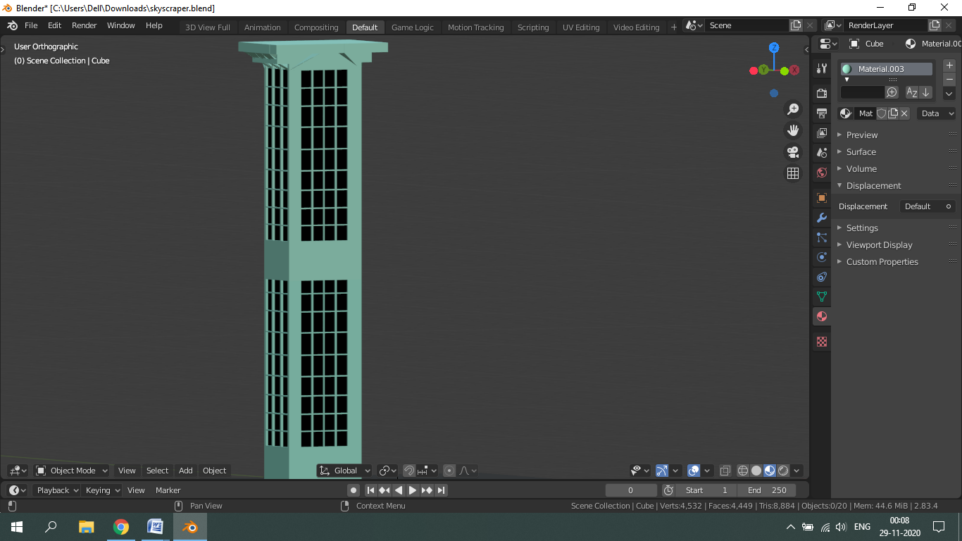

**Drive Link-**

<https://drive.google.com/drive/folders/1LG5iQRnM8Rk4wlkzVmeLJi2OiJRMzSTu?usp=sharing>